Images by Chapter

Chapter 1

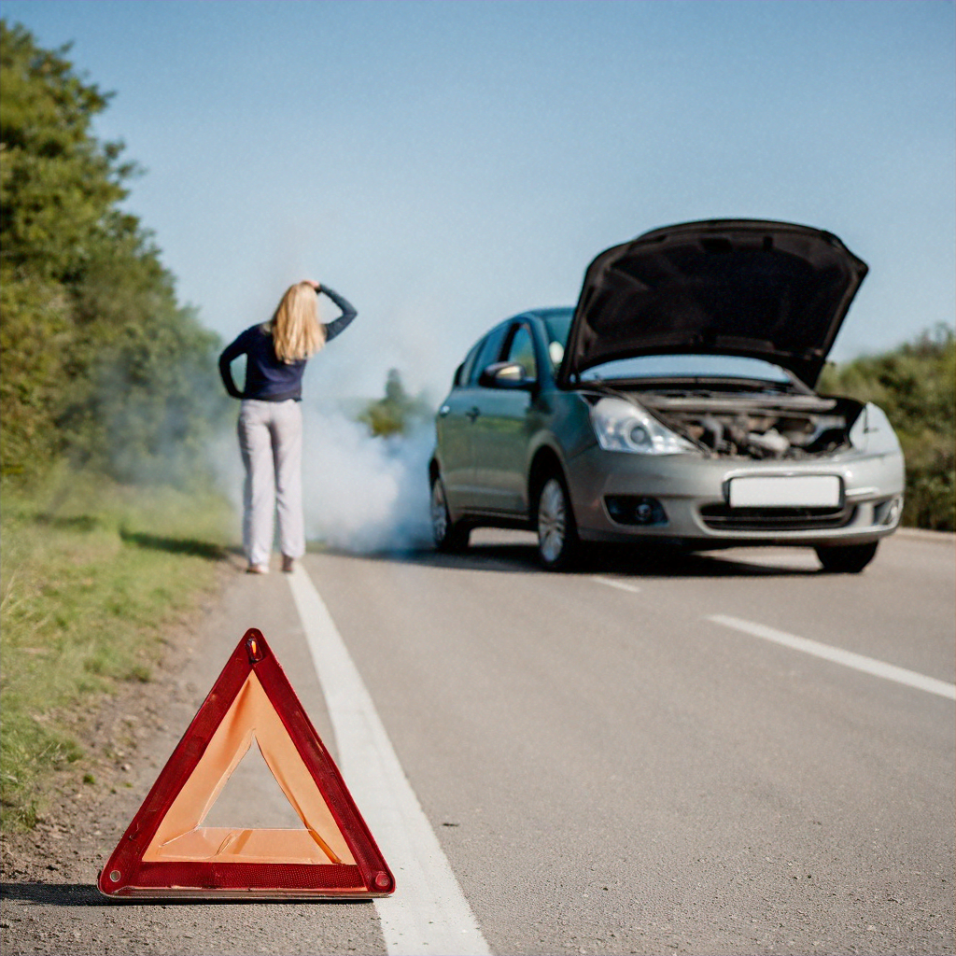

Figure 1.1: Essence of observability